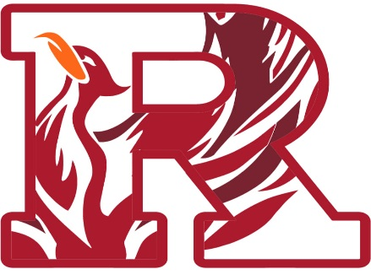

**2021/2022 DETROIT RENAISSANCE BOYS’ VARSITY BASKETBALL**

SAT 11/20 – AWAY @ AKRON ST. VINCENT-ST. MARYS (FIRESTONE HS EXHIBITION) 5:00 pm

SAT 11/27 – AWAY @ LIVONIA STEVENSON (SCRIMMAGE) 10:00 am

FRI 12/3 – AWAY @ NORTHVILLE (SCRIMMAGE) 7:00 pm

1. TUE 12/7 – AWAY @ ROMULUS SUMMIT ACADEMY NORTH 7:00 pm
2. SAT 12/11 – AWAY @ DETROIT UPREP (HORATIO WILLIAMS TIP-OFF CLASSIC) 12:00 pm
3. **FRI 12/17 – HOME VS. DETROIT MUMFORD (*PSL DIVISION*)** 4:00 pm
4. **WED 12/22 – HOME VS. BEVERLY HILLS BROTHER RICE** 7:00 pm
5. MON 12/27 – AWAY @ MICHIGAN COLLEGIATE (ROUNDBALL CLASSIC) 2:50 pm
6. WED 12/29 – AWAY @ CANTON (NORTH FARMINGTON HOLIDAY EXTRAVAGANZA) 5:15 pm
7. SAT 1/1 – AWAY @ TBD (MAC JELKS INVITATIONAL IN HAMMOND, INDIANA) 1:00 pm
8. **TUE 1/4 – HOME VS. DETROIT PERSHING (*PSL DIVISION*)** 4:00 pm
9. **FRI 1/7 – HOME VS. DETROIT DENBY (*PSL DIVISION*)** 4:00 pm
10. TUE 1/11 – AWAY @ DETROIT HENRY FORD (*PSL DIVISION*) 4:00 pm
11. **FRI 1/14 – HOME VS. DETROIT SOUTHEASTERN (*PSL DIVISION*) – “Senior Night”** 4:00 pm
12. TUE 1/25 – AWAY @ DETROIT CASS TECH (*PSL DIVISION*) 4:00 pm
13. FRI 1/28 – AWAY @ DETROIT KING (*PSL DIVISION*) 4:00 pm
14. SUN 1/30 – AWAY @ DETROIT EDISON (LITTLE CAESARS ARENA) 12:00 pm
15. FRI 2/4 – AWAY @ DETROIT DOUGLASS (*PSL DIVISION*) 4:00 pm

FRI 2/11 – PSL 1ST ROUND

TUE 2/15 -- PSL QUARTERFINALS

THU 2/17 – PSL SEMIFINALS

SAT 2/19 – PSL CHAMPIONSHIP

FRI 2/25 – Battle of Champions (PSL Champs vs CL Champs)

STATE PLAYOFFS (ROAD TO BRESLIN CENTER BEGINS)

* MARCH 7TH / 9TH / 11th – DISTRICTS
* MARCH 14th & MARCH 16TH – REGIONALS
* MARCH 22ND -- QUARTERFINALS
* MARCH 24TH – SEMIFINALS
* MARCH 26TH – STATE CHAMPIONSHIP GAME